
DBMS ASSIGNMENT (5)
(DATABASE MANAGEMENT SYSTEM)

NAME: Khushal Agarwal
SECTION: A
CLASS ROLL NO: 29
UNIVERSITY ROLL NO: 201500340

Write SQL queries for the following:
1. IDs and names of students who have applied to major in CS at some college.
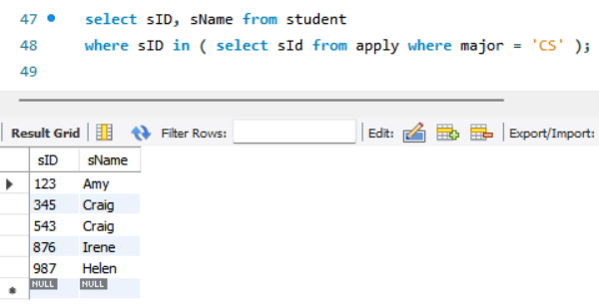
2. Find ID and name of student having same high school size as Jay.
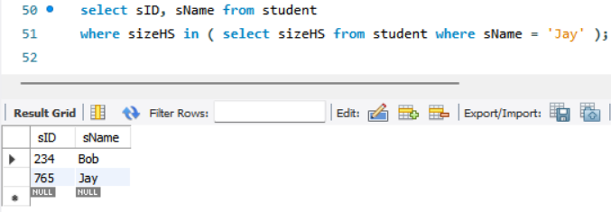
3. Find ID and name of student having same high school size as Jay but result should not include Jay.
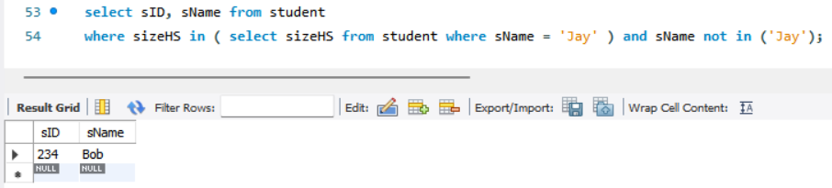
4. Find the name of student with their GPA and Sid whose GPA not equal to GPA of Irene?
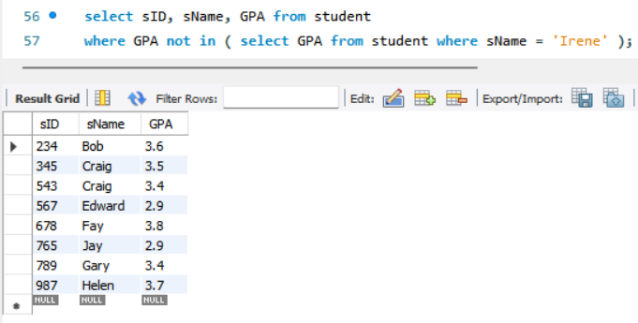
5. Find college where any student having their name started from J have applied?
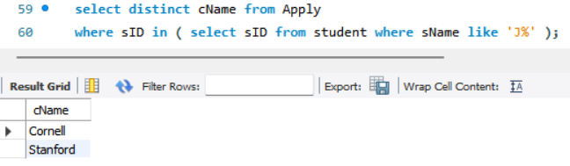
6. Find all different major where Irene has applied?
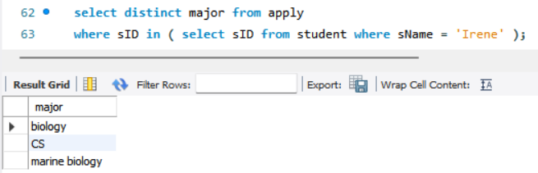
7. Find IDs of student and major who applied in any of major Irene had applied to?
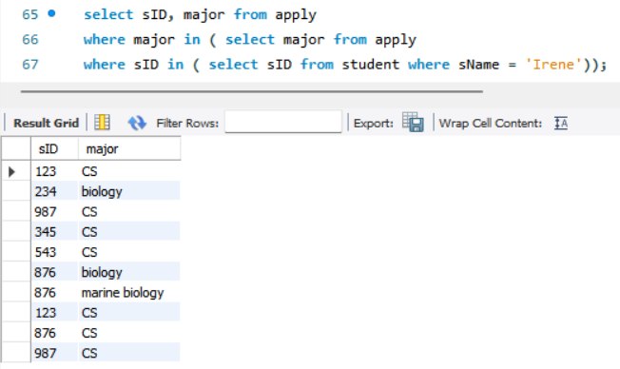
8. Find IDs of student and major who applied in any of major Irene had applied to? But this time exclude Irene sID from the list.
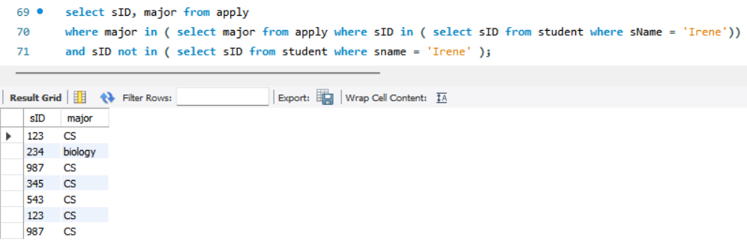
9. Give the number of colleges Jay applied to? (Remember count each college once no matter if he applied to same college twice with different major)
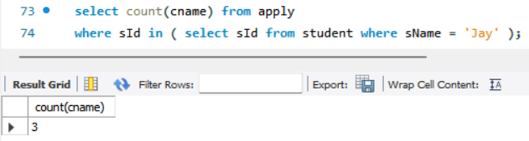
10. Find sID of student who applied to more or same number of college where Jay has applied?
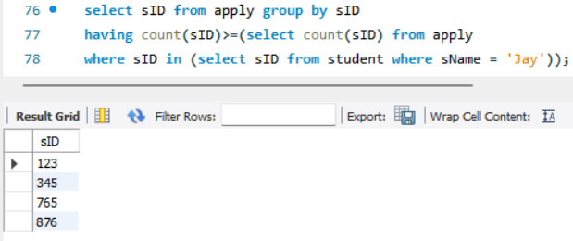

11. Find details of Students who applied to major CS but not applied to major EE? (sID 987, 876, 543 should only be include in result).
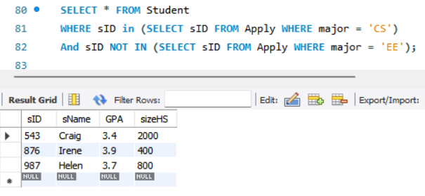
12. All colleges such that some other college is in same state. (Cornell should not be part of result as no other college in New York Hint: use exists)
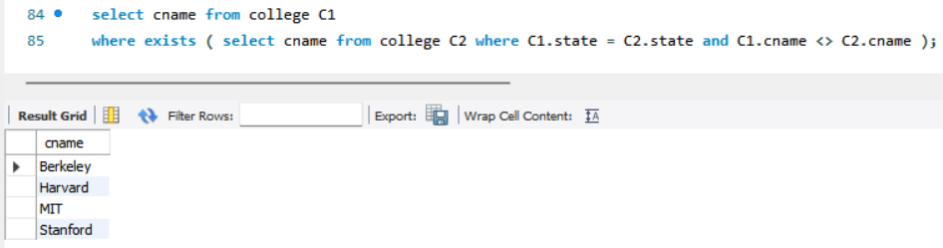
13. Find the college with highest enrolment.
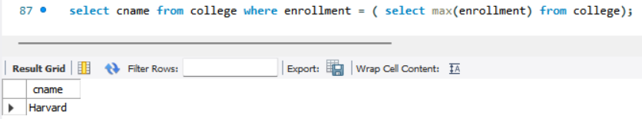

14. Find name of student having lowest GPA.
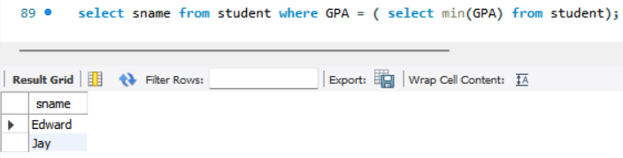
15. Find the most popular major.
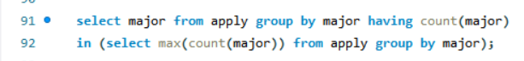
16. Find sID, sName, sizeHS of all students NOT from smallest HS.
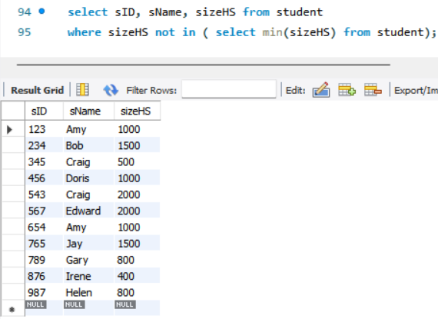

17. Find the name of student who applies to all the colleges where sID 987 has applied?
(Hint: see Query Find IDs of student applied to all colleges)
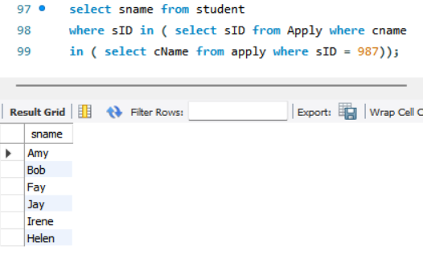

18. Find college where all the student have applied. For next three queries you are expected to solve using without joins and IN operators.
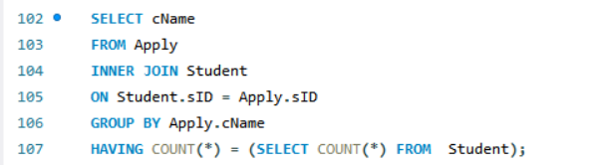
19. Find sID of student who have not applied to Stanford.
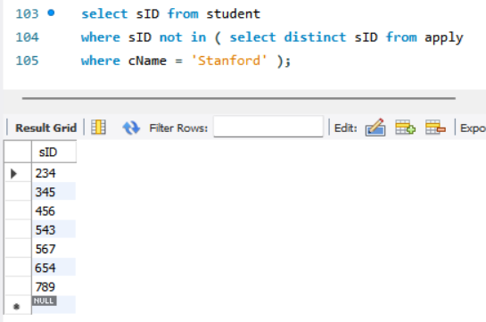

20. Give list of all names including all names of colleges and students.
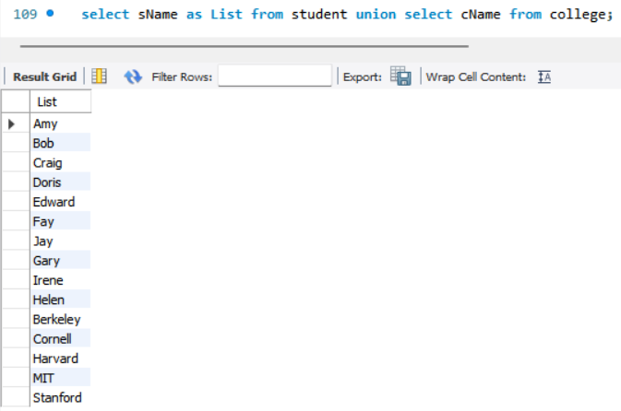

21. Create a table ApplicationInfo having columns sID: int, sName: varchar2(10) and number_of_applications: number(2) they filed? Populate this table with appropriate data using insert command.
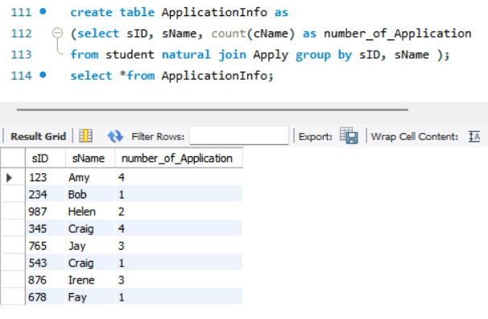
22. Create table ApplicationData and load with ID, name and college where they applied with state of college (remember to include details of ALL students that have applied or not applied) on runtime using single query.
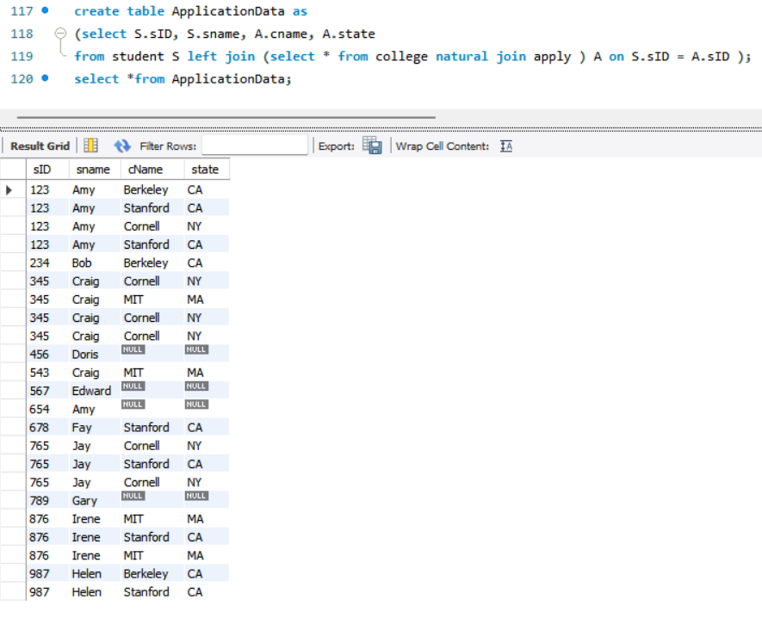
23. Stanford decide not to take any student who have also applied to its rival Berkeley turn their application decision to N.
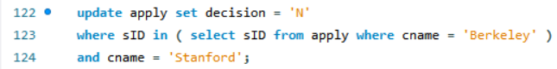
24. Delete applications that are filed to city ‘New York’.
